Concessions

Do you want to decrease your Band dues? Do you have a student (age 12 and over) needing service hours? Do you want to meet other Band families? Come work concessions with us!

Here’s how to sign up…

- Go to cougarband.org

- Click on “Charms / Calendar”

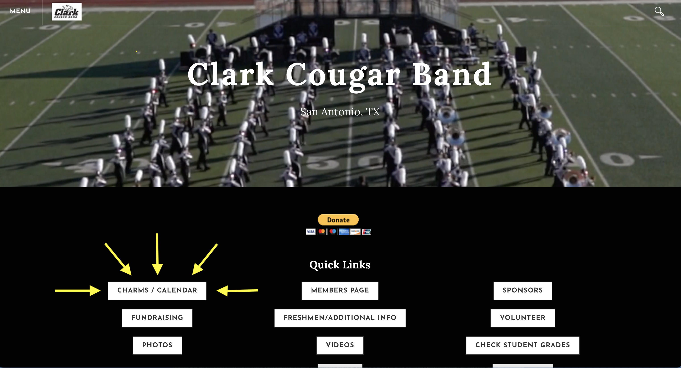

- Click on “Charms Parent Area”

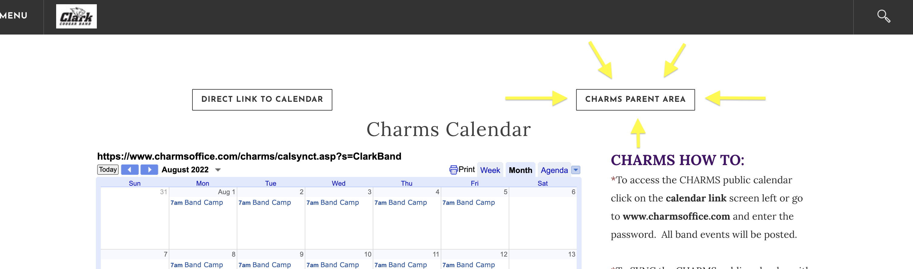

- Select the “Calendar” tab. Scroll through the months using the arrows on either side of the month name.

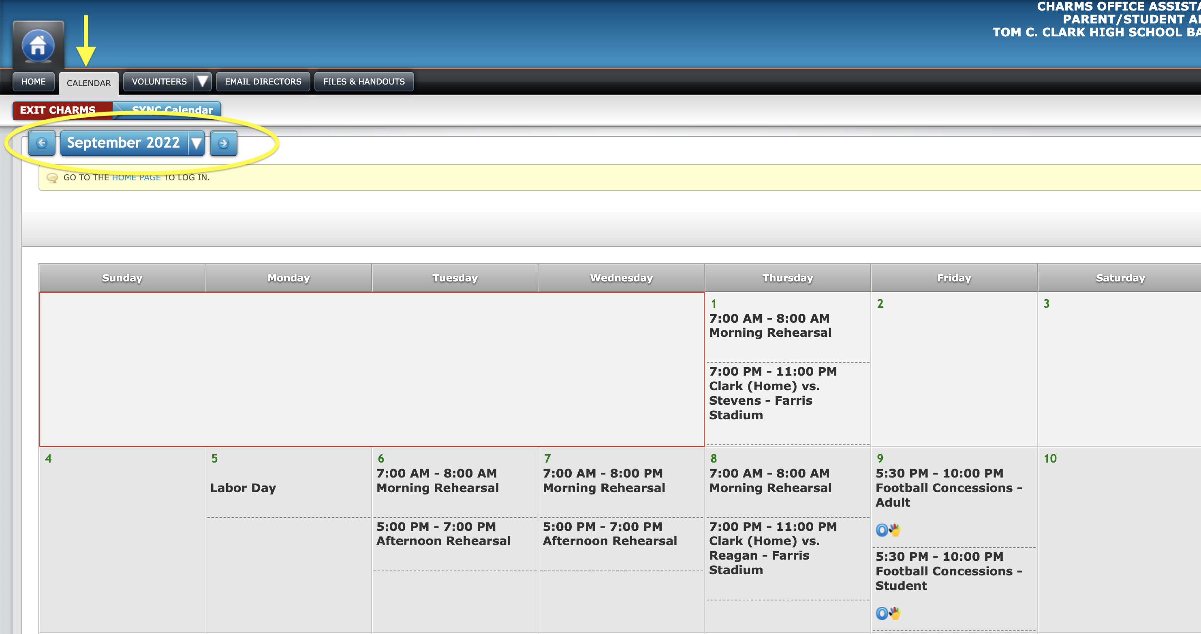
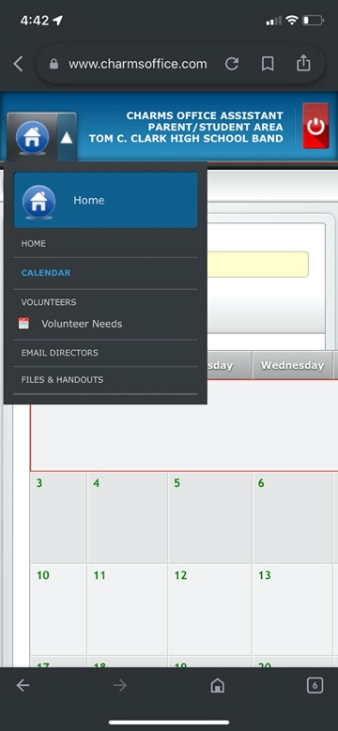

*If you are signing up on a phone, click the arrow beside
the home icon and select “calendar” from the drop down.

- Locate a concessions opportunity for you, your student, your mom, your best friend's sister's boyfriend's brother's girlfriend (or anyone who would like to work for your student’s account).

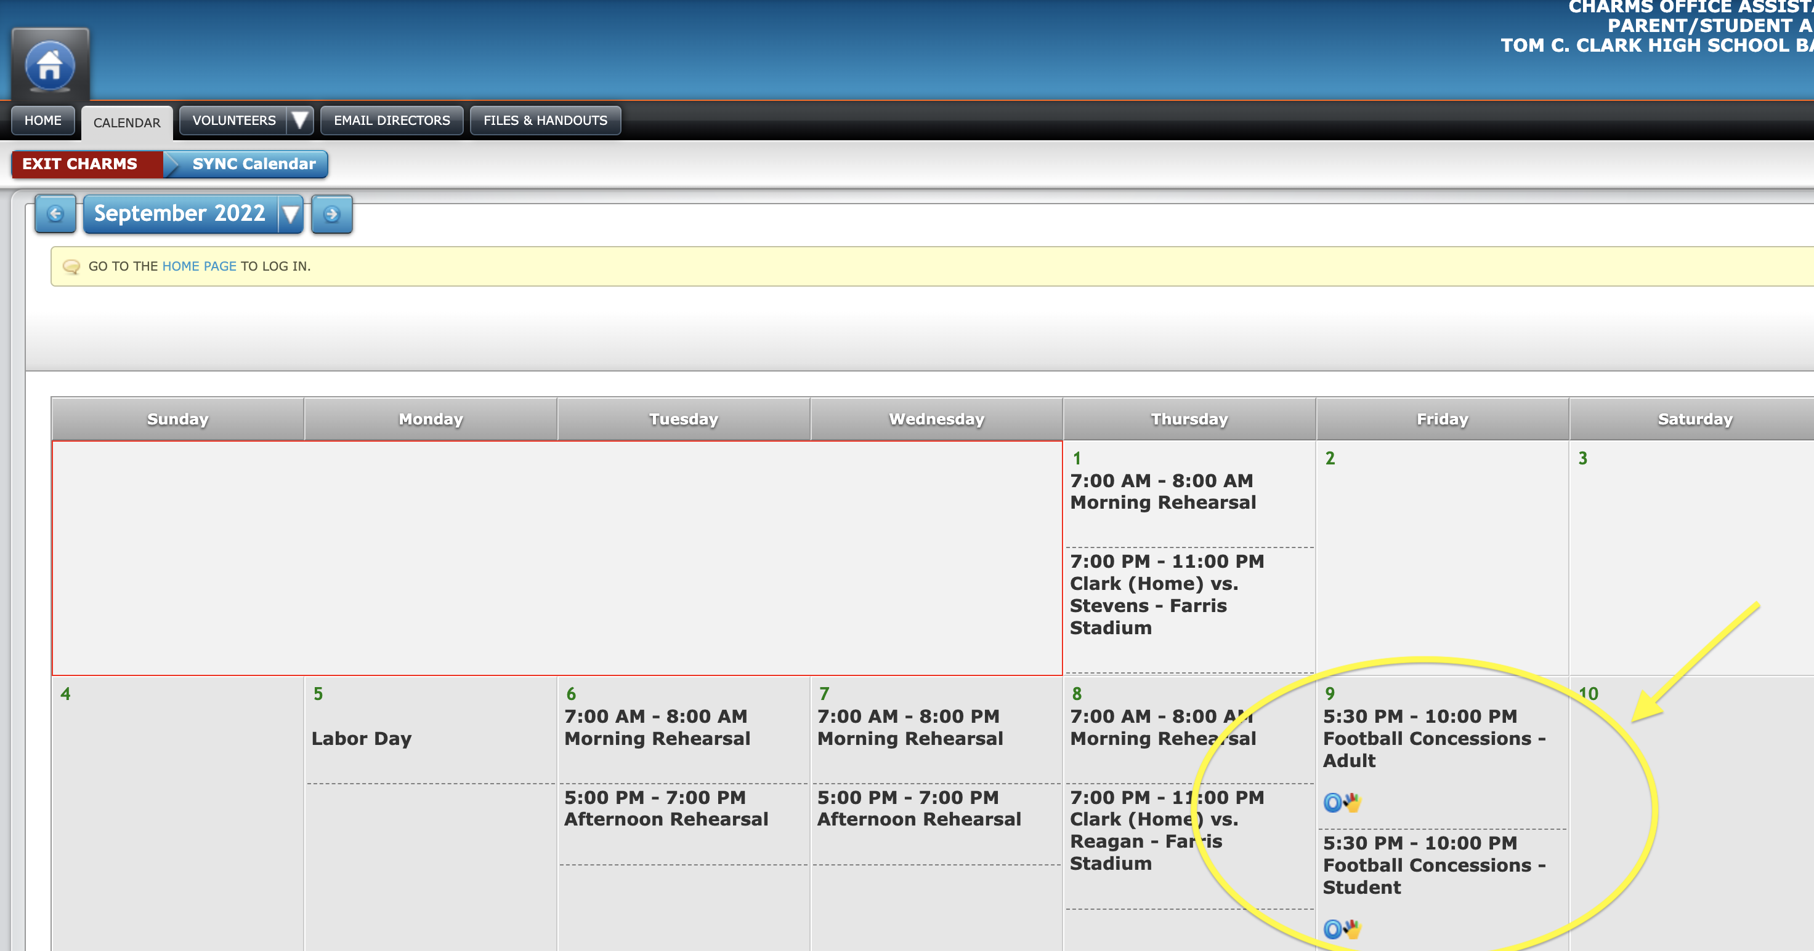

- Click the multi-colored hand highlighted below. Note that there is a separate sign up for Adults and Students.

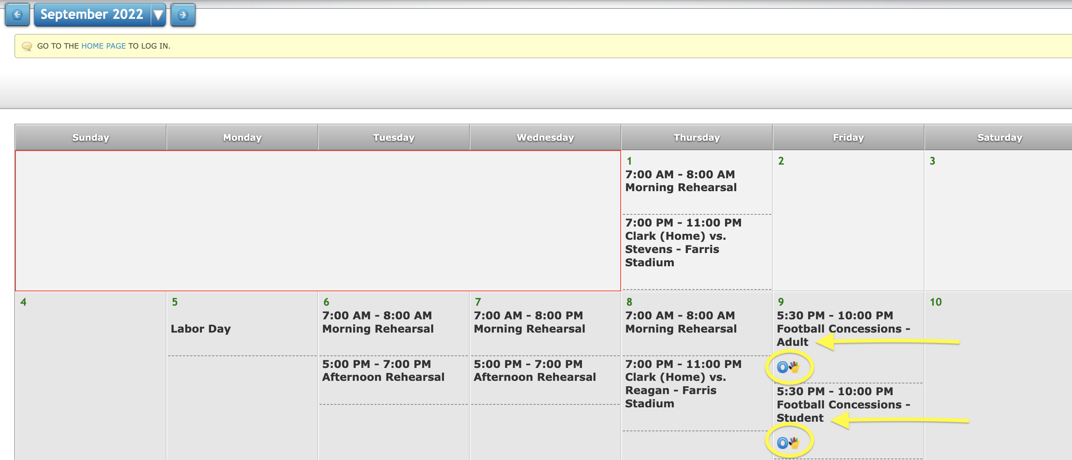

- Relevant details will be provided for each concession opportunity. Fill in your name, cell, email and then click “sign up”. Your contact info will be hidden. Don’t forget to sign up for adults and students separately! Please call or email with ANY questions.

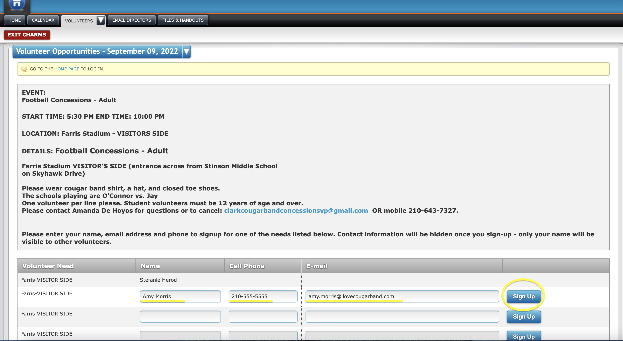

- You will receive a reminder email several days before your shift.
Please wear a Cougar Band shirt (or Clark HS shirt), a hat, and closed toe shoes.

THANK YOU SO MUCH! We appreciate you and your help matters!!!

